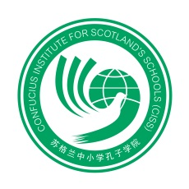
‘Nanjing Little Red Flower Art Troupe’
Booking Form

Evening Performance
Friday, 7 February 2014
Royal Concert Hall
Glasgow
19.30- 21.30

Please fill in the application form below listing the names of individuals who will attend the performance and return to Katie Hawkins at CISS, by close of business on Friday 31 January– katie.hawkins@strath.ac.uk

Please complete in BLOCK CAPITALS

NAMES:
Email address (for confirmation):

